# RANDOM VARIABLES

## ROLLING A FAIR 6‐FACED DICE (DISCRETE VALIABLE)

* Plot the histogram of the outcome values

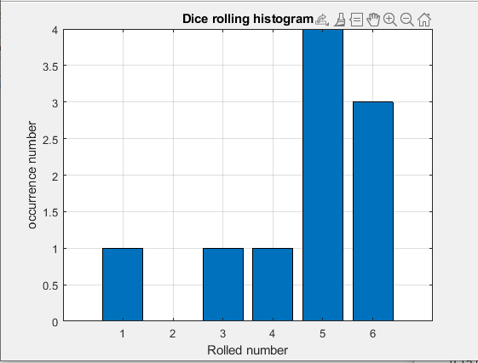

* Plot the normalized histogram

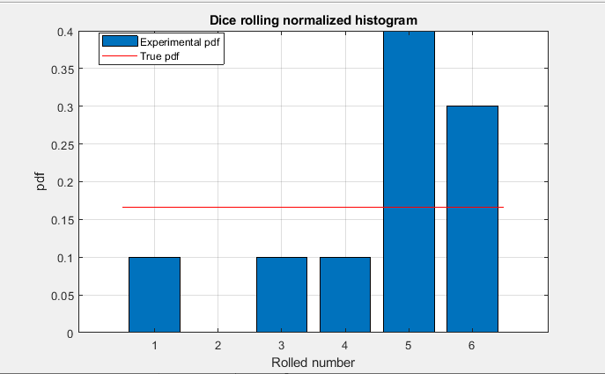

* Are the true pdf and the experimental pdf perfectly equal?

No, when we do experimental we cannot fit perfectly biased dice. Hence, cannot get true PDF.

* Is the experimental pdf varying between simulations?

Yes, it is vary

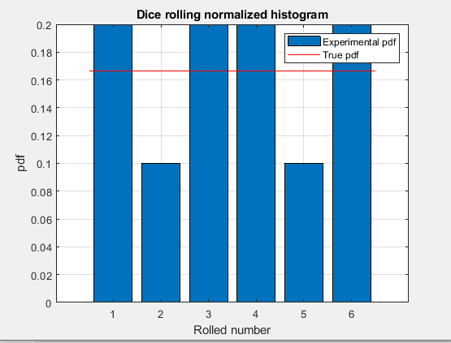

* Is the experimental pdf varying between simulations now?

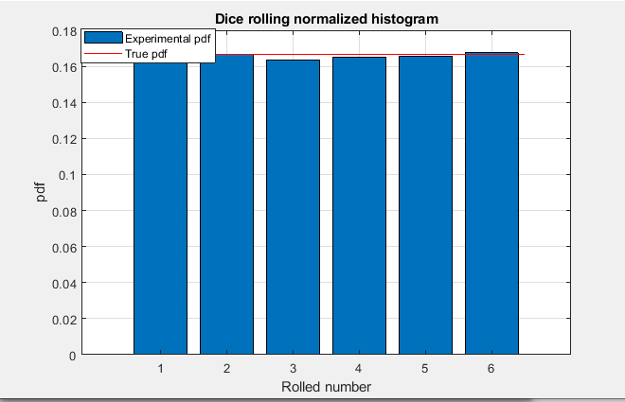

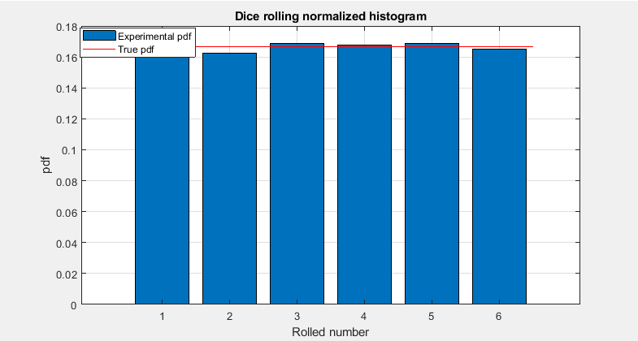

When number of trial increase, PDF is same since large number of sample probability is not changing much.

## NORMAL/GAUSSIAN DISTRIBUTED RANDOM VARIABLE

* Calculate the following statistics of the observed samples.

Mean: 3

Standard deviation: 2

Variance: 4

* See the difference in the fitting between the experimental pdf and the analytic pdf as the number of samples changes

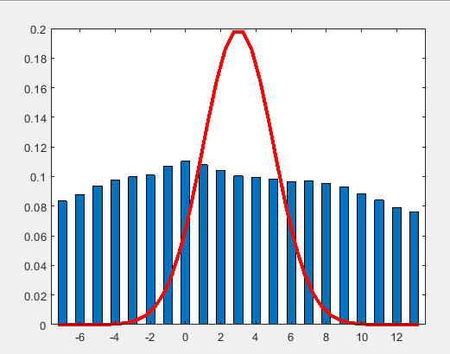

* Integrate histogram bins

Probability of X>5.25 = 0.3548

* Check your answer with the Q‐function

Q‐function P(X>b)= Q((b-μ)/σ) = 0.1303

# RANDOM PROCESSES

## WHITE NOISE VS. COLORED NOISE

* Plot the noise signal

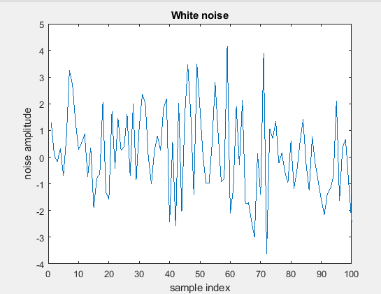

* Histogram of the noise signal

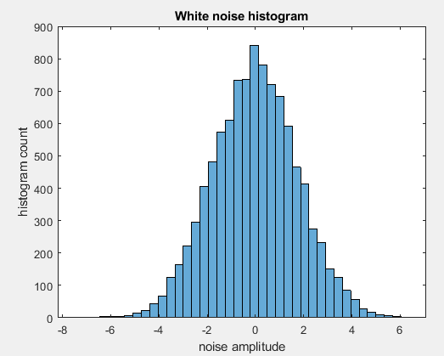

* Plot the impulse response and amplitude (frequency) response

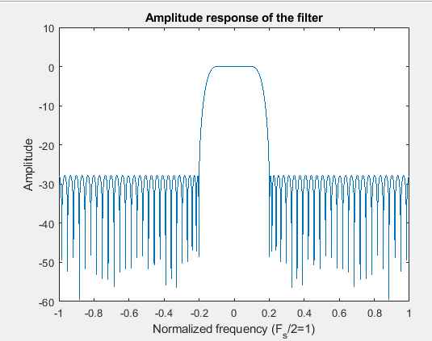

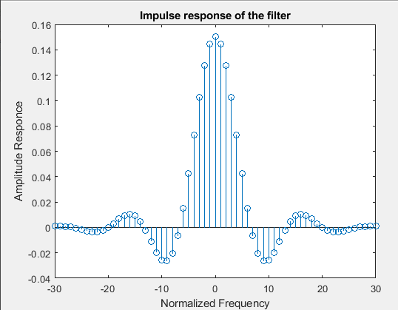

* White noise and filtered noise signals

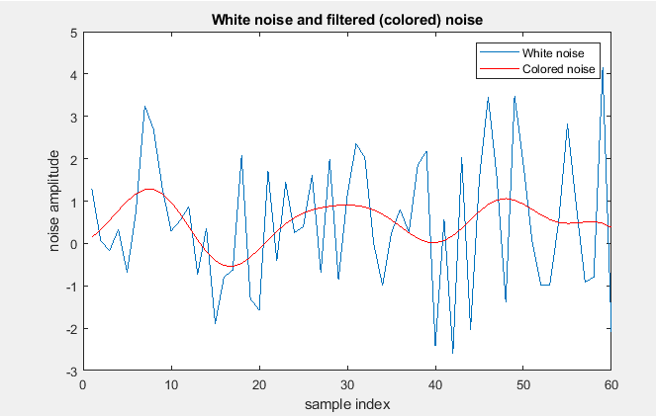

* How it is distributed?

A linear time-invariant (LTI) system can be represented by its impulse response

* What type of autocorrelation function should the white noise have?

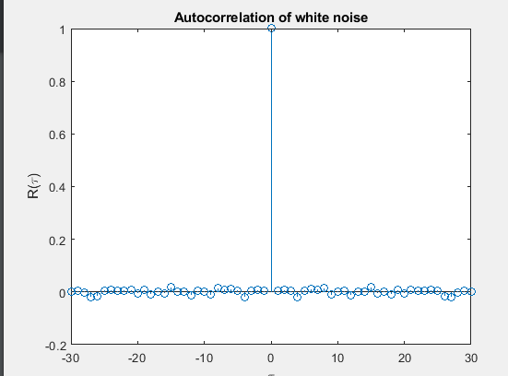

Impulse at 0

* Autocorrelation function of the filtered noise signal

The autocorrelation of filtered white noise equals the autocorrelation of the filter's impulse response times the white-noise variance.

In the frequency domain, we have that the true power spectral density of filtered white noise is the squared-magnitude [frequency response](http://www.dsprelated.com/dspbooks/filters/Frequency_Response_I.html) of the filter scaled by the white-noise variance.

* Compare this with the previously plotted impulse response of the filter
* Gaussian noise and white noise

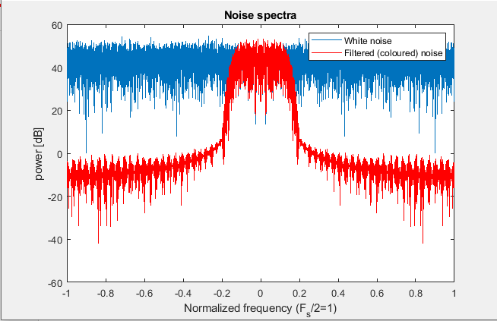

* What is the connection between the correlation function and the power spectral density function?

Power spectrum density is basically Fourier transform of auto-correlation function of power signal. Its Fourier transform is power spectral density.

Here both noise signals are Gaussian, but only the other one is white because it is a random signal having equal intensity at different frequencies, giving it a constant power spectral density. On the other hand, Gaussian noise has probability density function (PDF) equal to that of the normal distribution, which is also known as the Gaussian distribution

## RANDOM WALK MODEL (EXAMPLE FROM THE CLASSROOM EXERCISES)

* Realizations of the random walk process

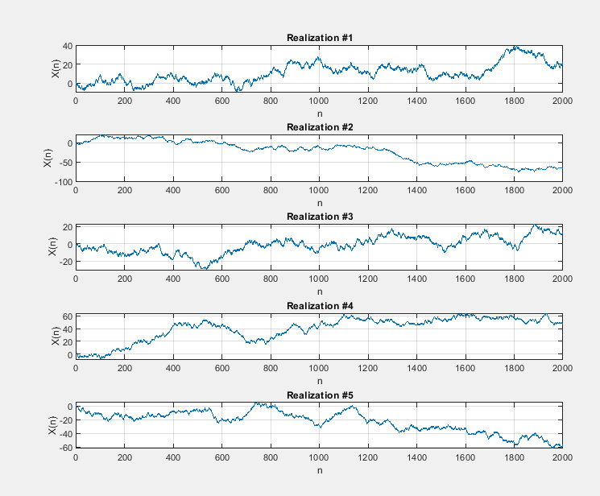

* Calculated ensemble mean and variance

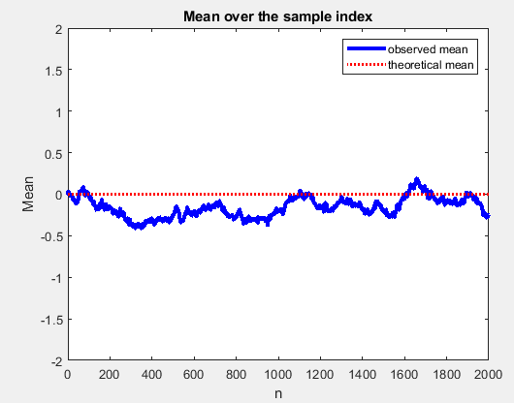

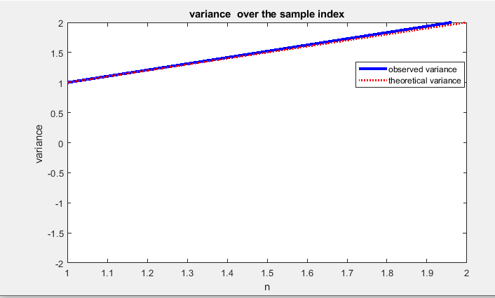

Re‐run the process with different values of p, s, and try different number of realizations

Due to memory issues, do not try too many realizations at the same time (stay below 100000 realizations and 2000 samples)

* Is the process stationary (in wide sense)? Why? /Why not?

Random walk is not a stationary process. Since variance is increases linearly with n this is not stationary processes as well as not time invariant.

Realization : 7000

Samples : 1000

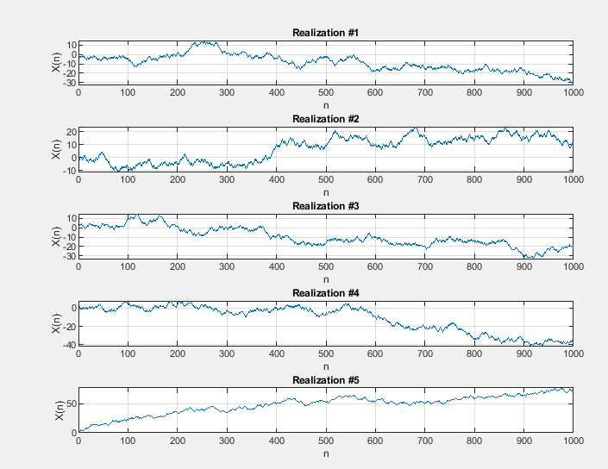

Realization : 9000

Samples : 500

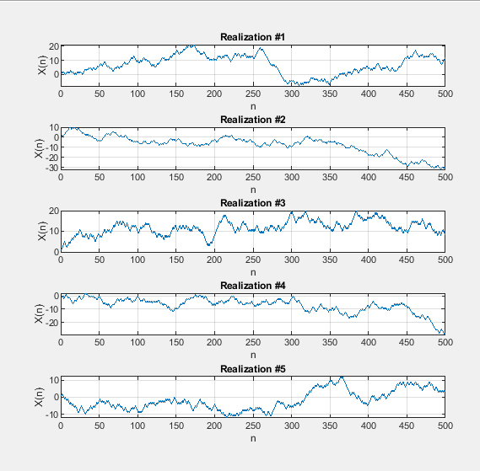

* What if the number of realizations is very low?

Realization : 100

Samples : 2000

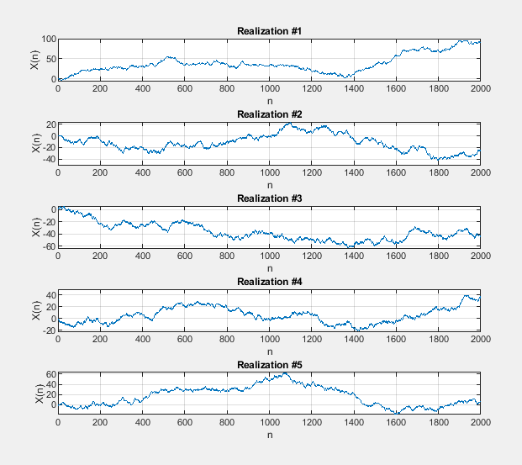

# Matlab Codes

